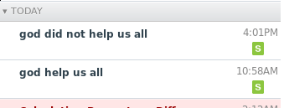

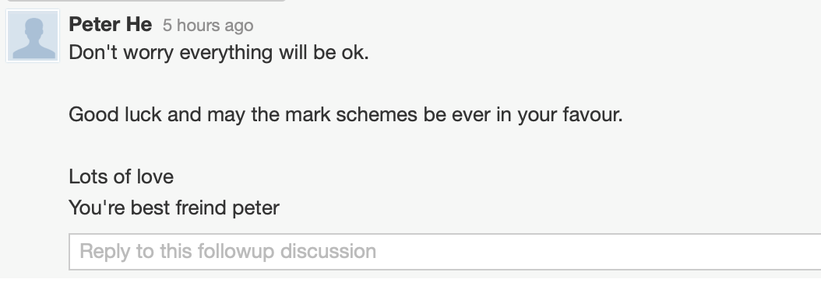yy

^^^^^^^^LIARRRRRRRRRRRR^^^^^^^^^^^

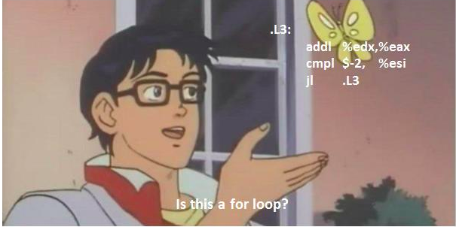

Help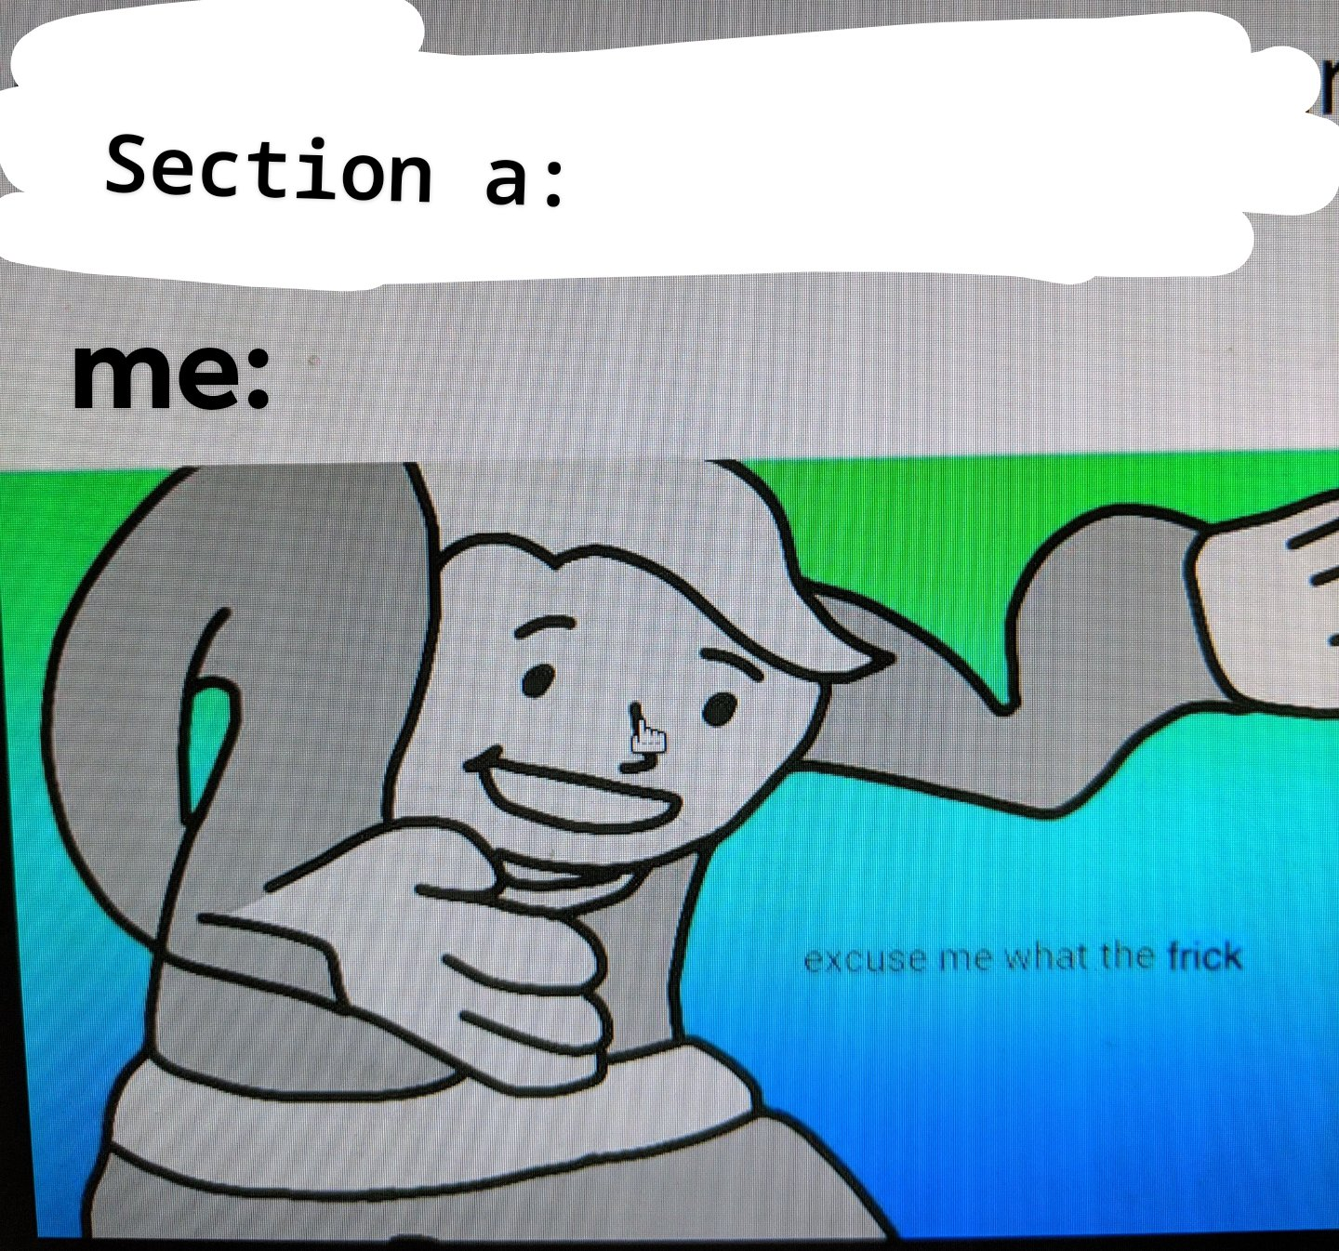

Inb4 Wayne says close but not quite.

do i get a 50% refund in tuition after that, since we got 50% less teaching

I smell an email complaint

HAVE WE OFFENDED THOSE TEACHERS IN ANY WAY???????!!!!!!!!

SRL WHAT THE FK HAPPENED？？？？？？？？？

Aw

imagine it's fill in the blanks, and the blanks are wrong.

1. a) wh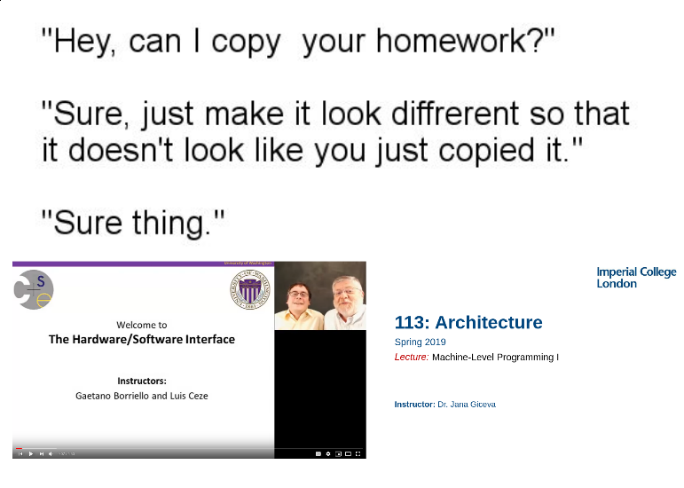o knows

b) some boxes

c) more boxes

d) even more boxes

2.

a)

By Devesh Erda:

int loop(int a, int b) {

int x, y;

y = 10*a + b;

for (x = 4*y; b < x; y += 3*a) {

x = -2;

}

return y;

}

Jana’s content is so next level it introduces the halting problem in 15% of architecture.

Something like this? It doesn’t match the template...

int loop(int a, int b) {

int x, y;

y = 10a + b;

if (b < 4 * y) {

for (x = 3 * a; b < -2; ) {

y += x;

}

}

return y;

}

**Umer’s solution**

There wasn’t an if condition in the template, what are you on about. i think it’s generally agreed that the template was shite. Who knows. I fit the template, because that is what was definitely right? And if it definitely wasn’t right, get ready for that 100%. Go do db everyone.

Int loop(int a, int b) {

Int x,y;

Y = 10a + b;

For (x = 3a, x >= b; x -= 2) {

Y = y + x;

}

Return y;

}

^ most important point. Go do Databases, not worth getting hung up on arch and screwing ourselves over for the rest :( Thomas has been a jokes lecturer so it would be good of us to at least give the exam a good effort too 😊✌️